**Operating Systems - Lab 05 Revision-Lab Tasks**

Ibrahim Johar Farooqi

23K-0074

BAI-4A

28 February 2025

**Lab Questions:**

**Task 1:**

**Create a directory called project in your home directory.**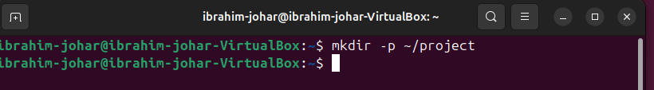

**Task 2:**

**Navigate to the project directory.**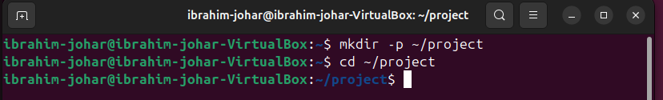

**Task 3:**

**Create an empty file named task1.txt in the project directory.**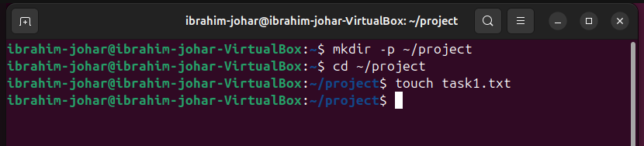

**Task 4:**

**List all files in the current directory using the ls command. Create a file called file1.txt.**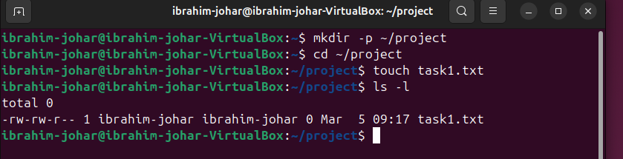

**Task 5:**

**Change the permissions of the file file1.txt so that only the owner has read and write**

**permissions, and others have no permissions.**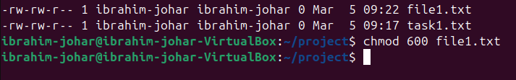

**Task 6:**

**Check the permissions of file1.txt using the ls -l command.**

**Task 7:**

**Grant execute permissions to the owner of the file file1.txt.**

**Task 8:**

**Display the current working directory using the pwd command.**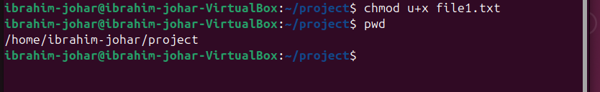

**Task 9:**

**Show the current date and time using the date command.**

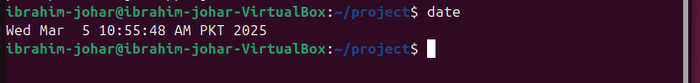

**Task 10:**

**Display your system’s disk usage with the df -h command.**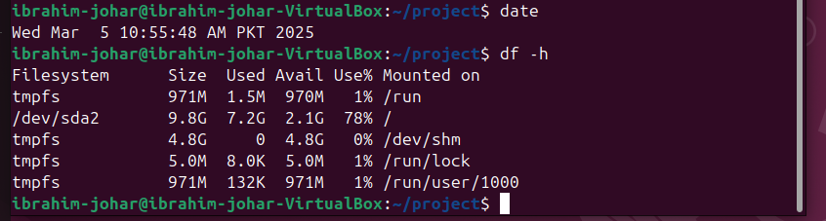

**Task 11:**

**Display system uptime using the uptime command.**

**Task 12:**

**Show all users currently logged into the system using the who command.**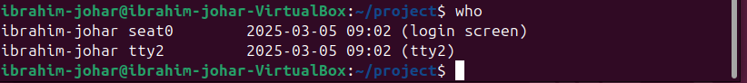

**Task 13 & 14:**

**Take a filename as input and count number of lines**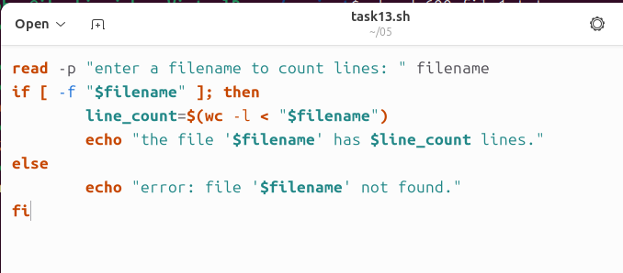

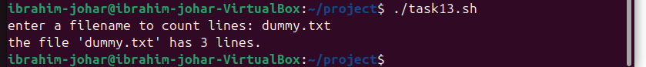

**Task 15:**

